Admin Membership Application
Review

Mobile UI
No. | Screenshot | Review
1.
2.

PC UI
No. | Screenshot | Review
1 | 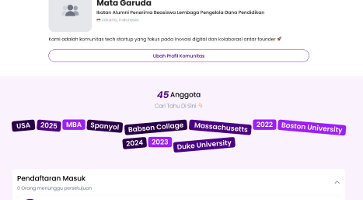 | - Tombol admin untuk gabung blm ada
2 |  | - Komunitas > [community abbreviation] > Gabung Keanggotaan
3 | 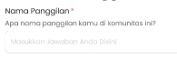 | - Urutan kedua setelah nomor keanggotaan
4 | 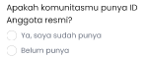 | - Urutan pertama sebelum nama panggilan  - Product requirement:  - Allow community managers to activate manual Member ID for their community.  - When Member ID is activated:  - Existing members (real) can enter the Member ID already created by the community when registering to communities in Kolavo. For new members who do not yet have a Member ID, the community manager can assign one before accepting them.  - System prevents duplicate Member ID within the same community.  - Automatic Member ID generation is out of scope for V1.  - Design requirement:  - Question Membership ID  - Label: Nomor Keanggotaan  - Description/question: Isi nomor keanggotaan jika ada  - Seperti ini ya, pakai field sama seperti pertanyaan lain.  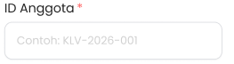
5 | 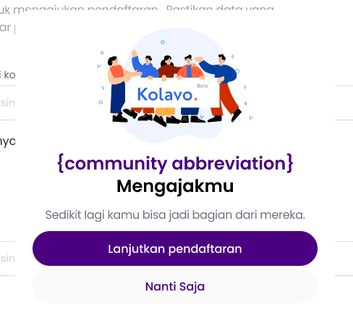 | - Background modal dark transparan

